Computer networks

MICRO PROJECT REPORT ON COMPUTER NETWORKS
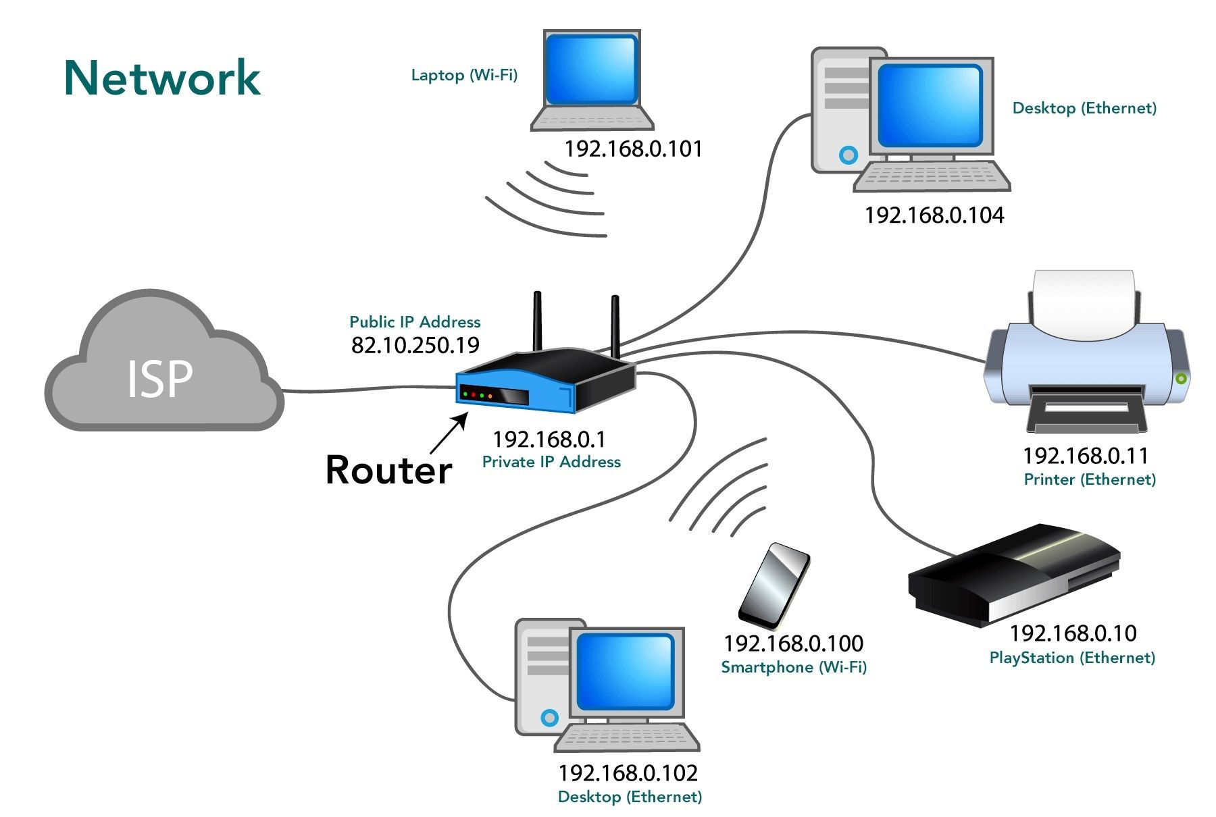

1. INTRODUCTION

A computer network is defined as a system of interconnected computing devices (such as computers, servers, mainframes, network devices, peripherals, or other devices) that can exchange data and share resources with each other. These devices are linked together using communication channels and data links (either wired or wireless). The primary goal of establishing a computer network is to facilitate communication, enable resource sharing (hardware and software), and ensure data integrity and security across an organization or globally.

The modern world is entirely dependent on computer networks, ranging from small-scale Local Area Networks (LANs) used in homes and offices to the massive Wide Area Networks (WANs) that form the internet.
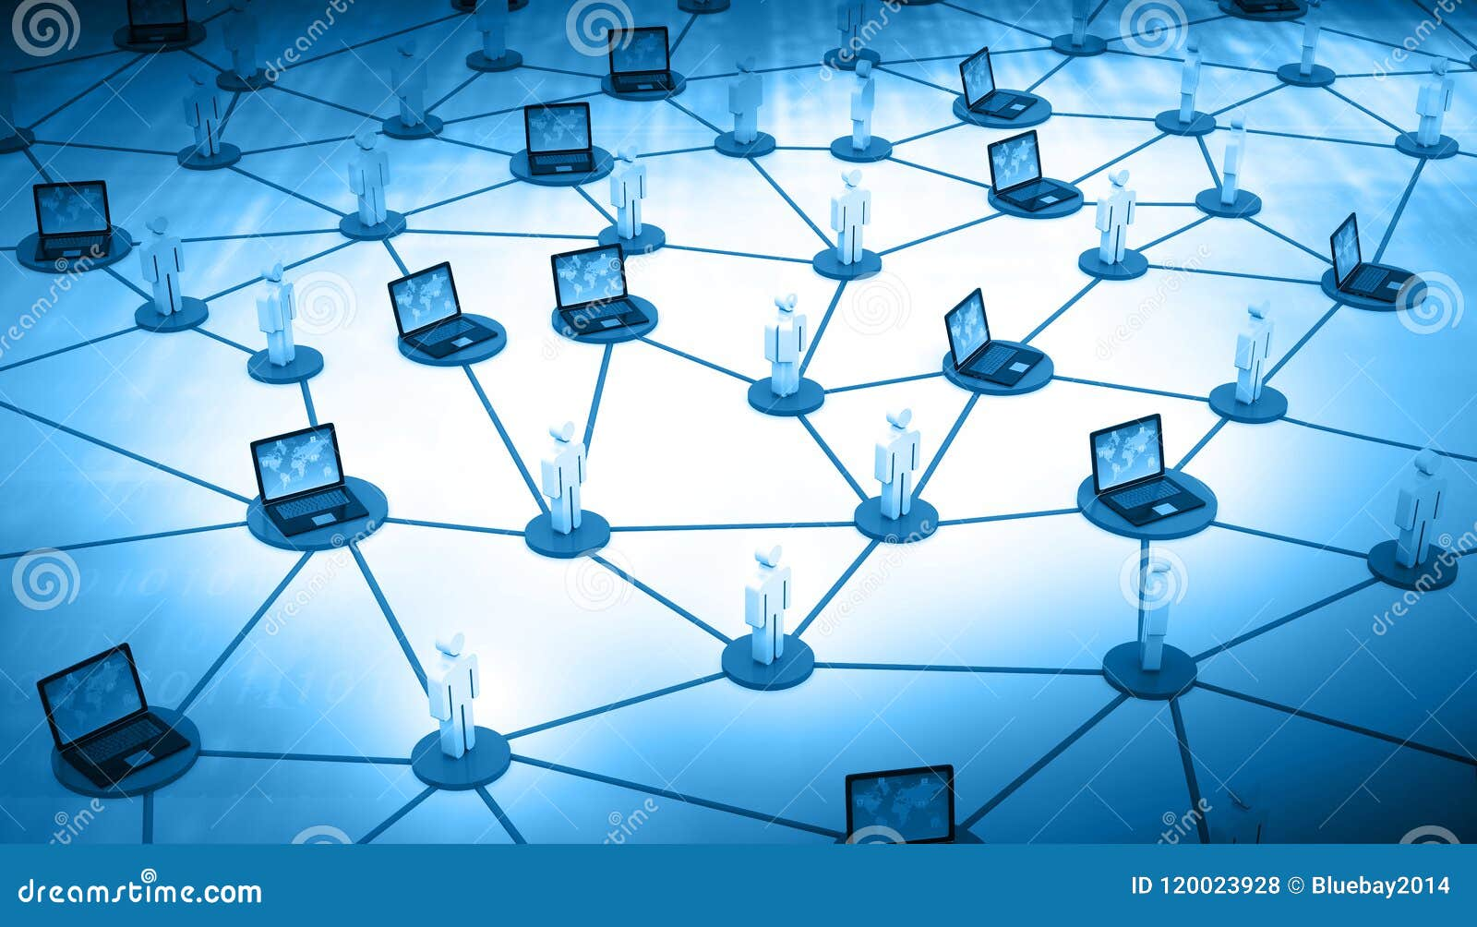
This project report details the fundamental principles, historical evolution, operational mechanisms, and diverse applications of computer networks, providing a comprehensive overview suitable for engineering study.

2. HISTORY

The evolution of computer networks is intrinsically linked to the need for efficient data sharing and communication, particularly within governmental and academic institutions.

2.1 Early Concepts and Packet Switching (1960s)
The foundational concept of packet switching, where data is broken into small, manageable units (packets) for transmission, was developed independently by Paul Baran and Donald Davies. This was crucial for creating robust, fault-tolerant networks.

2.2 The Birth of ARPANET (Late 1960s)
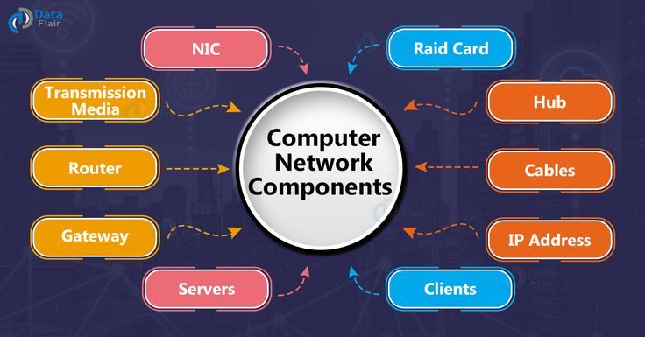
The Advanced Research Projects Agency Network (ARPANET), funded by the U.S. Department of Defense, is considered the precursor to the modern internet. It successfully linked several university and research computers, demonstrating the feasibility of wide-area networking. The first message was sent in 1969.

2.3 Standardization and TCP/IP (1970s)
The development of the Transmission Control Protocol/Internet Protocol (TCP/IP) suite by Vint Cerf and Bob Kahn provided a standardized, reliable method for communication between disparate networks. TCP/IP became the standard proocol for ARPANET in 1983, leading to the term "Internet."
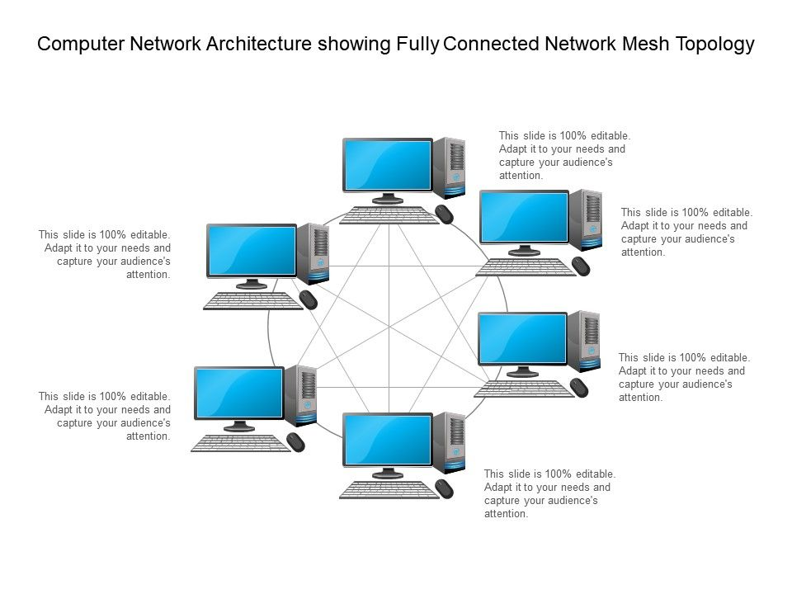
2.4 Commercialization and Ethernet (1980s)
The 1980s saw the widespread adoption of Ethernet technology (developed by Xerox PARC), which became the dominant standard for LANs. As government restrictions on commercial use were lifted, networking moved from academia into the business sector, accelerating growth.

2.5 The World Wide Web (1990s)
Tim Berners-Lee’s invention of the World Wide Web (WWW), along with HyperText Transfer Protocol (HTTP) and Uniform Resource Locators (URLs), democratized the internet, making it accessible to the general public and leading to exponential growth in network traffic and complexity.
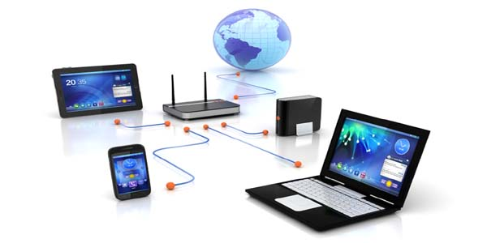

3. WORKING PRINCIPLE

Computer networks operate based on a layered architecture, primarily defined by the TCP/IP model (or the more theoretical OSI model), and rely fundamentally on packet switching and standardized addressing.
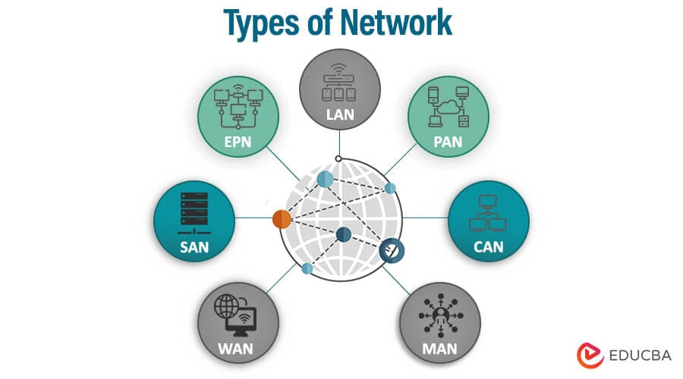
3.1 Layered Architecture
Data transmission is broken down into distinct stages, handled by different layers (e.g., Application, Transport, Internet, Link). Each layer performs specific functions, such as error checking, segmentation, addressing, and physical transmission. This modularity ensures interoperability between different hardware and software systems.

3.2 Packet Switching
When a user sends data (e.g., an email or a file), the Transport Layer segments the data into smaller units called packets. Each packet contains a portion of the data along with header information, including the source and destination IP addresses. These packets are then routed independently through the network.

3.3 Addressing and Routing
Two primary addressing schemes are used:
- IP Addressing: Logical addresses (e.g., IPv4 or IPv6) used by routers to determine the optimal path across the internet.
- MAC Addressing: Physical addresses embedded in the Network Interface Card (NIC), used for local communication within a segment.
Routers use complex algorithms to analyze the destination IP address of each packet and forward it along the most efficient path until it reaches the destination network.

3.4 Protocol Standardization
Protocols (rules) govern every aspect of network communication. For instance, TCP ensures reliable, ordered delivery of packets, while UDP (User Datagram Protocol) offers faster, connectionless transmission suitable for streaming.

4. METHODOLOGY

The methodology employed in this project report focuses on comprehensive literature review, comparative analysis, and conceptual modeling to understand the structure and function of computer networks.

4.1 Literature Review and Data Collection
Extensive review of academic papers, industry standards (IEEE, IETF), and technical documentation was conducted to gather reliable information regarding network protocols, topologies, and security mechanisms.

4.2 Comparative Analysis of Topologies
Different network topologies (Star, Bus, Ring, Mesh) were analyzed based on criteria such as cost, reliability, fault tolerance, and ease of expansion to determine their suitability for various organizational needs.

4.3 Protocol Stack Analysis
Detailed analysis of the TCP/IP protocol stack was performed to understand the interaction between different layers and how data encapsulation and decapsulation occur during transmission and reception.

4.4 Conceptual Modeling of Network Components
Modeling the roles of key networking hardware (routers, switches, hubs, firewalls) was undertaken to understand their functional placement and contribution to overall network performance and security.

5. CLASSIFICATION

Computer networks are classified based on several criteria, primarily their geographical scope, the medium used, and their architectural design.

5.1 Classification by Scale (Geographical Scope)
- Personal Area Network (PAN): Used for connecting devices within a person's immediate workspace (e.g., Bluetooth, USB). Range: up to 10 meters.
- Local Area Network (LAN): Connects devices within a limited area, such as a single building or campus. Characterized by high data rates and low error rates.
- Metropolitan Area Network (MAN): Spans a city or a large campus. Often connects multiple LANs together.
- Wide Area Network (WAN): Covers large geographical distances, often connecting countries or continents (e.g., the Internet). Characterized by lower data rates and higher latency compared to LANs.

5.2 Classification by Topology
- Star: All nodes connect to a central hub or switch. Highly reliable but dependent on the central device.
- Bus: All nodes share a single communication line. Simple but difficult to troubleshoot.
- Ring: Nodes are connected in a closed loop. Data flows in one direction.
- Mesh: Every device is connected to every other device. Highly redundant and fault-tolerant, but expensive to implement.

5.3 Classification by Architecture
- Client-Server: Centralized model where servers provide resources and services to client machines.
- Peer-to-Peer (P2P): Decentralized model where all devices have equal status and can act as both client and server.

6. TYPES
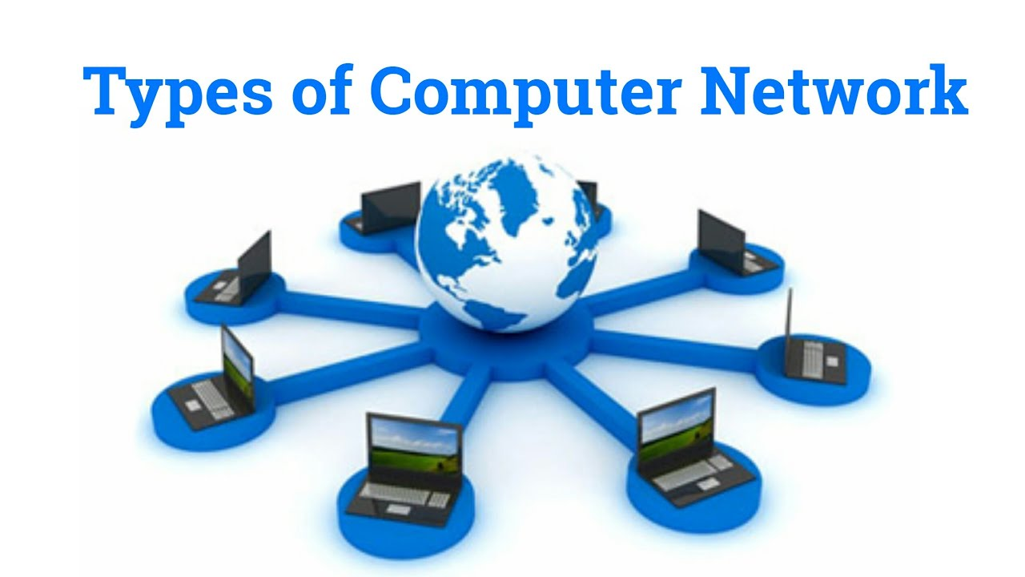

While classification covers the criteria, the following are the most common practical types of networks implemented today.

6.1 Intranet
A private network utilizing Internet Protocol technology, restricted to an organization. It functions like a private version of the internet, used for internal communication and resource sharing.

6.2 Extranet
An extension of an organization’s Intranet that allows controlled access to authorized external users (e.g., suppliers, customers, partners) over the internet.

6.3 Storage Area Network (SAN)
A dedicated high-speed network that provides access to consolidated, block-level data storage. It is typically used by servers and makes storage devices appear locally attached.

6.4 Wireless Networks (WLAN, WWAN)
Networks that use radio waves or infrared signals instead of physical cables. Wireless LANs (Wi-Fi) are common in homes and offices, while Wireless WANs (cellular networks like 4G/5G) provide mobile connectivity over vast areas.

7. APPLICATIONS

Computer networks are integral to nearly every facet of modern life and business operations.

7.1 Resource Sharing
Enabling multiple users to share expensive resources like printers, scanners, centralized databases, and high-performance computing clusters, significantly reducing operational costs.

7.2 Communication and Collaboration
Facilitating instant global communication through email, Voice over IP (VoIP), video conferencing, and instant messaging, supporting remote work and global team collaboration.

7.3 E-commerce and Financial Transactions
Providing the infrastructure necessary for secure online shopping, banking, stock trading, and the transfer of digital currency.

7.4 Distributed Processing
Breaking down complex computational tasks into smaller parts that can be processed simultaneously by multiple networked computers, improving speed and efficiency (e.g., cloud computing).

7.5 Entertainment and Information Access
Supporting streaming media (video and audio), online gaming, and providing universal access to information via the World Wide Web.

8. RESULTS

The successful implementation and analysis of computer network principles yield several measurable results critical for modern infrastructure.

8.1 Enhanced Efficiency and Speed
The study confirms that using standardized protocols (TCP/IP) and high-speed media (Fiber Optic, Gigabit Ethernet) results in significantly reduced data transfer times and improved operational efficiency compared to standalone systems.

8.2 Reliable Data Transfer
Through the use of error detection and correction mechanisms inherent in protocols like TCP, networks achieve highly reliable data transfer, ensuring that packets are delivered completely and in the correct order.

8.3 Global Connectivity
The layered architecture and routing protocols successfully enable seamless interconnection between diverse hardware platforms and geographical locations, forming the backbone of the global internet.

8.4 Cost Reduction
By centralizing data storage, software licenses, and hardware peripherals, networks demonstrably reduce the total cost of ownership (TCO) for organizations.

9. ADVANTAGES

9.1 Centralized Data Management
Data can be stored on central servers, making backups, security, and access control far simpler and more robust.

9.2 Scalability
Networks can be easily expanded by adding new nodes, switches, or routers without needing to redesign the entire infrastructure.

9.3 Flexibility and Remote Access
Users can access files and resources from any device connected to the network, facilitating mobility and remote working capabilities.

9.4 Cost-Effectiveness
Sharing resources like software licenses, storage devices, and high-quality peripherals across multiple users drastically reduces per-user costs.

10. DISADVANTAGES

10.1 Security Risks
Networks are vulnerable to external attacks (hacking, malware) and internal threats. Maintaining network security requires constant vigilance and sophisticated firewalls/intrusion detection systems.

10.2 High Initial Setup Cost
Implementing large-scale networks requires significant investment in hardware (routers, servers, cabling) and specialized software.

10.3 Reliance on Central Server
In client-server architectures, if the central server fails, the entire network operation may halt, leading to significant downtime.

10.4 Management Complexity
Large networks require highly skilled personnel for continuous maintenance, troubleshooting, and configuration management, adding to operational expenses.

11. CONCLUSION

Computer networks represent the foundational technology of the information age. From their origins in ARPANET to the complex, high-speed wireless infrastructures of today, networks have continuously evolved to meet the increasing demand for global connectivity and resource sharing. Understanding the layered architecture, packet switching principles, and diverse classifications (LAN, MAN, WAN) is crucial for any engineering professional. While networks present challenges related to security and complexity, the overwhelming advantages in efficiency, collaboration, and economic benefit solidify their role as the indispensable backbone of modern communication and commerce. Future developments, particularly in Software-Defined Networking (SDN) and the Internet of Things (IoT), promise even greater flexibility and integration.

12. REFERENCES

- Tanenbaum, A. S., & Wetherall, D. J. (2021). Computer Networks (6th ed.). Pearson Education.
- Kurose, J. F., & Ross, K. W. (2020). Computer Networking: A Top-Down Approach (8th ed.). Pearson Education.
- Stallings, W. (2017). Data and Computer Communications (10th ed.). Pearson Education.
- IEEE Standards Association Documentation (Various years). Ethernet and Wireless LAN Standards.

